SUGAR MAS 47 SENIOR CALYPSO SEMI FINALISTS ANNOUNCED

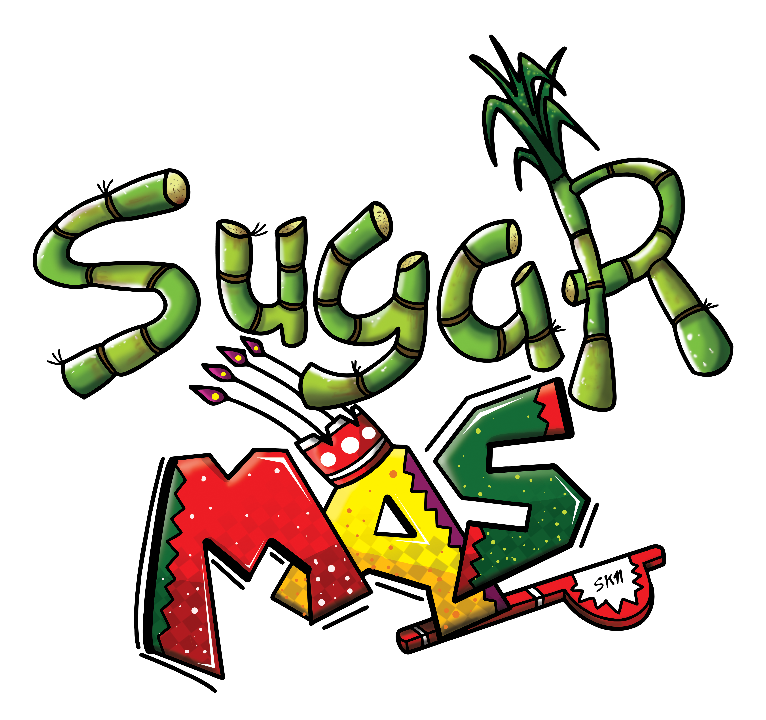
Monday 3rd December, 2018 (St. Kitts & Nevis) – The St. Kitts Nevis National Carnival Senior Calypso Eliminations concluded on Sunday 2nd December, 2018. Eliminations where held on Saturday 1st and Sunday 2nd December, to select the 16 Semi Finalists. Sixteen (16) Calypsonians performed on Saturday whereas nineteen (19) performed on Sunday.

Prior to the Eliminations, Calypso Tents were held by both The Legends and Proud Sound bands, which also played for the Calypsonians on the night of the Eliminations.

After a very tough time at judging the creative and talented Calypsonians with their melodious voices and strong lyrical content, the Judges brought in the results for the Senior Calypso Semi-Finalists as follows:
Queen Kibie - 394 Points
Brown Sugar – 391 Points
Charis D – 380 Points
Genesis – 361 Points
Lil Miss – 358 Points
King Godfrey – 358 Points
Singing Jackie – 355 Points
De Awesome Navigator – 345 Points
Queen Diva – 342 Points
Unexpected – 339 Points
Hollywood – 339 Points
Singing Sharon – 332 Points
Lord Kut – 329 Points
Glenroy Blanchette – 321 Points
Lord Payne – 319 Points
Lady B – 316 Points
ALTERNATE – Jack Spanner
The judging criteria for the Eliminations were:
Lyrics - 40 Points
Performance – 30 Points
Music – 30 Points
Total -100 points

The Calypsonians will perform on Sunday 16th December at the Senior Calypso Semi Finals to be held at the Carnival City, after which, seven (7) will move on to the Finals to compete with the reigning Calypso Queen, Miss Independent.

The National Carnival Committee extends heartfelt thanks and appreciation to all Judges, Audiors – Grant Thornton, Calypsonians and the St. Kitts Nevis National Carnival Committee volunteers for a successful two nights of Calypso.

Follow us on facebook for more information!

