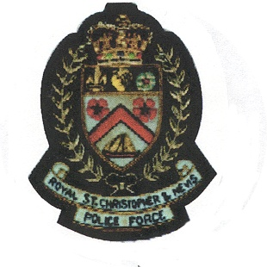
THE ROYAL ST. CHRISTOPHER AND NEVIS POLICE FORCE

WANTED

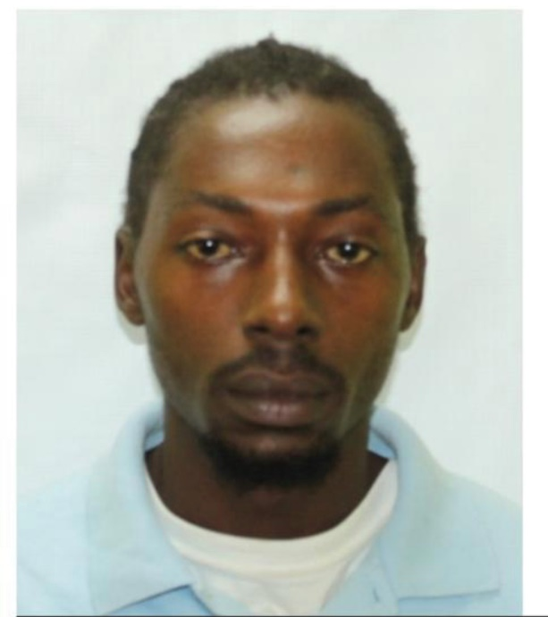

Name: Jahvon mills
ADDRESS: st. peters
D.O.B: 24-10-1988
AGE: 30 years
Place of Birth: st. kitts
complexion: dark brown
HAIR: BLACK
EYES: black
HEIGHT: 5ft 7’’

A warrant, in the first instance, exists for the arrest of Jahvon mills of st. peters for the offence of escaping lawful custody. ANYONE WHO SEES HIM OR KNOWS OF HIS WHEREABOUTS IS ASKed TO CONTACT THE BASSETERRE POLICE STATION 465-2241, or THE NEAREST POLICE STATION.

