St. Christopher Air & Sea Ports Authority
Presents
scaspa reports
Monday, 09th September 2019
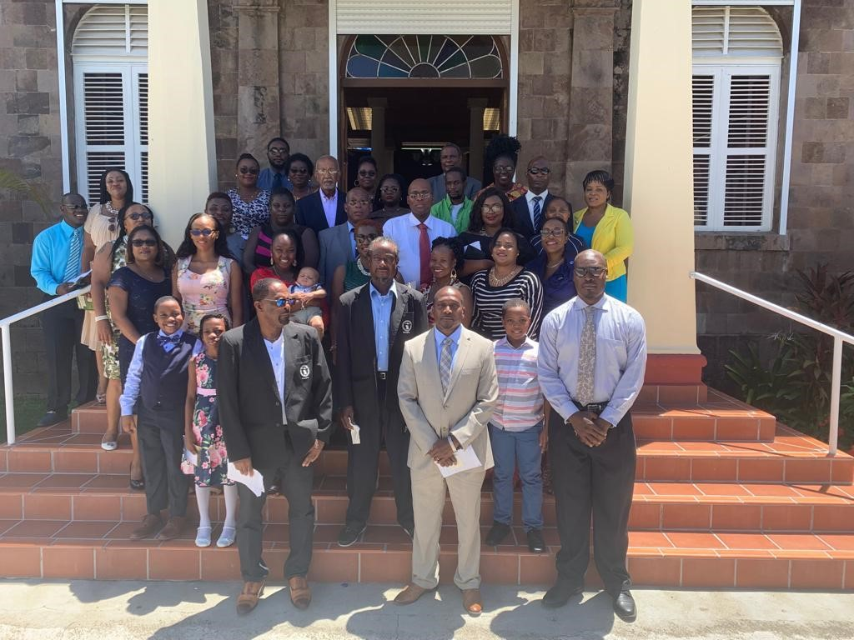

SCASPA celebrates 26 years of service in

St. Kitts and Nevis!

Bird Rock, Basseterre, St. Kitts  (Wednesday 11th September 2019)  September marks a month of memorable celebrations in St. Kitts and Nevis. Concurrent with our Nation’s 36th year of Independent celebrations, the St. Christopher Air & Sea Ports Authority (SCASPA) also celebrates its 26th year of servitude to the nation.  The month of celebrations commenced with a day of prayer and thanksgiving at the Wesley Methodist Church, Seaton Street, where the congregation warmly welcomed SCASPA’s Board, Management and staff. Thanksgiving worship was followed by a staff luncheon.  Other activities that form part of the Authority’s month of celebrations include; a Community Cleanup day slated for September 14; a health driven hike to Lawyer Stevens Cave on the 16th; and a special edition Radio “Port Call” Program.  Communities are welcome to celebrate SCASPA’s milestone by joining in on the exciting communal events such as the community clean up and hike adventure.  The St. Christopher Air & Sea Ports Authority (SCASPA) takes this time to thank its stakeholders and the community at large for the patronage, support and opportunity to serve and build the economy of St. Kitts and Nevis for the past 26 years.  Special thanks are also extended to the Management and staff of SCASPA for their continued dedication and commitment to making everyday lives of Kittitians and Nevisians easier, transportation of goods smoother and serving you – our customers, better! |  | For more photo highlights from the SCASPA Church Worship & Luncheon, or even keep abreast of whats happening at SCASPA, follow us and like our Facebook page  @ St. Christopher Air & Sea Ports Authority.  ###

