SCASPA PRESS RELEASE APRIL 02ND 2020
IMMEDIATE RELEASE - CARGO OPERATIONS FRI 03RD APRIL 2020
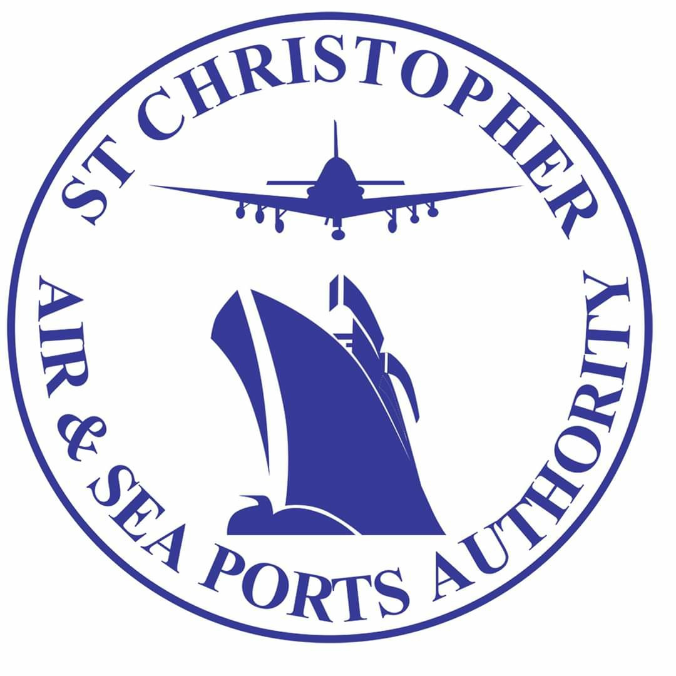
ST. CHRISTOPHER AIR & SEA PORTS AUTHPRITY
BASSETERRE, ST. KITTS - The general public is hereby advised that ALL transit sheds at the St. Christopher Air & Sea Ports Authority (SCASPA) will be opened and operational tomorrow Friday April 3rd 2020 from 8:00 A.M - 4:00 P.M.
Processing and Clearance services for Commercial business operators will be unrestricted while clearance of goods for private citizens will be restricted to food and medication ONLY.
It is important to note that strict practices for social distancing will be enforced and adhered to.
Please be guided accordingly.

