SCASPA PRESS RELEASE APRIL 11th 2020
IMMEDIATE RELEASE - MANDATORY FACE MASK AT SCASPA SAT 11TH APRIL 2020
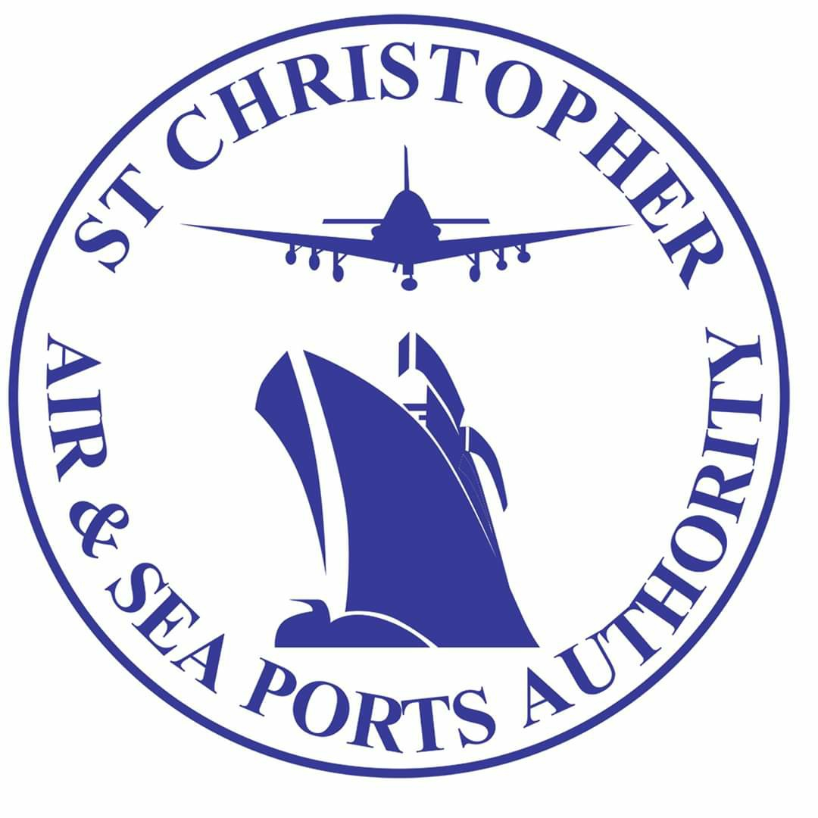
ST. CHRISTOPHER AIR & SEA PORTS AUTHORITY
BASSETERRE, ST. KITTS - In the interest of safety and to control the spread of the virus, the general public is hereby advised that all persons conducting business at SCASPA must wear some form of covering over their nose and mouth when accessing any SCASPA facility.That face covering can include a surgical mask, N95 mask, homemade mask, scarf, bandana or handkerchief.
Failure to comply will result in denied access onto the SCASPA Facility.

It is important to note that strict practices for social distancing will be enforced and adhered to.
Please be guided accordingly.

