PRESS RELEASE
FOR IMMEDIATE RELEASE
NEW SCASPA CARGO SHEDS OPERATION TIME.
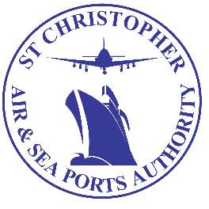

(Bird Rock, Basseterre, St. Kitts – Thursday 16th April 2020) - The general public is hereby advised that ALL transit sheds at the St. Christopher Air & Sea Ports Authority (SCASPA) will be opened and operational as follows;

- On Thursday 16th and Friday 17th April, 2020 between the hours of 8:00 A.M. – 2:00 P.M. clearance of goods for private citizens will be restricted to food and Medication ONLY. While between the hours of 8:00 A.M. – 4:00 P.M. Commercial Business Operators will be accommodated for unrestricted processing and clearance services.

- On Monday 20th, Tuesday 21st, Thursday 23rd and Friday 24th April 2020, between the hours of 8:00 A.M. – 2:00 P.M. - Private citizens will be accommodated for unrestricted clearance of goods, including vehicles. Between the hours of 8:00 A.M. – 4:00 P.M Commercial Business Operators will be accommodated for unrestricted processing and clearance services.

Please be reminded that strict practices for social distancing and the wearing of protective face masks or any form of covering that must cover the nose and mouth while conducting business at SCASPA will be enforced and adhered to.

Please be guided accordingly.

