

SAINT CHRISTOPHER AND NEVIS

Tel: (869)465-2335 **DEPARTMENT OF AGRICULTURE**

**Tel: 869-465-2110 VETERINARY AUTHORITY**

Fax: (869)465-2928 P O Box 39

E-mail: skbvet@hotmail.com La -Guerite

Basseterre St. Kitts, West Indies

**List of Countries from where importation of frozen meat and related items are permitted.**

|  |  |  |  |  |
| --- | --- | --- | --- | --- |
| Products | Pork | Beef | Poultry | Mutton |
| Countries | | | | |
| USA | Approved | Approved | Approved | Approved |
| Canada | Approved | Approved | Approved | Approved |
| UK | Approved | Approved | Approved | Approved |
| Australia | Approved | Approved | Approved | Approved |
| Brazil | Denied | Denied | Approved | Denied |
| Chile | Denied | Denied | Approved | Denied |
| European Union | Denied | Denied | Denied | Denied |
| St. Martin* | Denied | Denied | Denied | Denied |
|  | | | | |  |
| Barbados | Approved | Approved | Approved | Approved |  |
| Jamaica | Approved | Approved | Approved | Approved |  |
| St. Lucia | Approved | Approved | Approved | Approved |  |
| St. Vincent | Approved | Approved | Approved | Approved |  |
| Trinidad | Approved | Approved | Approved | Approved |  |
| New Zealand | Approved | Approved | Approved | Approved |  |

*If St. Martin is a third country for any of the above countries and the product is in its **original** package with the **country-of-origin stamp**: **Yes**

………………………………………………….

Dr. Kofi Sylvester  
C.V.O (Ag)  
Department of Agriculture  
November 23, 2023





Below are the Poultry Processing Plants that are eligible to export from Brazil to St. Kitts and Nevis.

|  |  |  |
| --- | --- | --- |
| BRF SIF number | Production Plant | State |
| 1 | Concordia | Santa Catarina |
| 104 | Chapeco | Santa Catarina |
| 466 | Capinzal | Santa Catarina |
| 716 | Toledo | Parana |
| 1001 | Rio Verde | Goias |
| 102 | Marau | Rio Grande do Sul |
| 160 | Campos Novos | Santa Catarina |
| 121 | Uberlandia | Minas Gerias |
| 1985 | Dois Vizinhos | Parana |
| 2518 | Francisco Betrao | Parana |
| 4567 | Novo Mutum | Mato Grosso |
| JBS SIF number | Production Plant | State |
| 490 aves | Seara | Santa Catarina |
| 2022 | Guapiacu | Soa Paulo |
| 2172 | Forquilhinha | Santa Catarina |
| 4202 | Ipumirim | Santa Catarina |
| 4430 | Itapetininga | Soa Paulo |
| 2423 | Brasilia | Distrito federal |
| 42 | Barra do Garcas |  |
| 2340 | Trinidade Do Sul | Rio Grande do Sul |
| 3470 | Confresa |  |



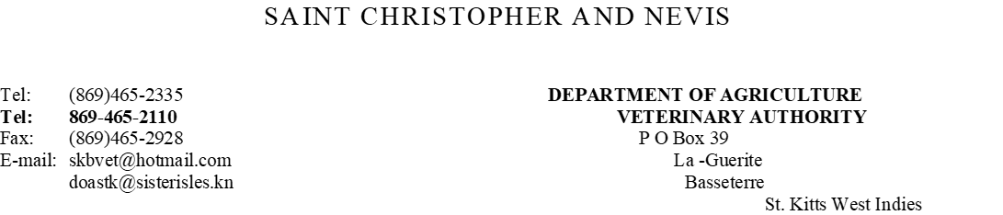

|  |  |  |
| --- | --- | --- |
| Number | Production Plant | State |
| 516 | Copacol | Cafelandia Parana |
| 2439 | Carrer Alimentos LTD | Farroupilha-RS |
| 601 |  |  |
| 2512 | Aurora | Santa Catarina |
| 3357 | Mauricea Alimentos | Santa Catarina |
| 2815 | Mauricea Alimentos | Santa Catarina |
| 3125 | Itajaia | Santa Catarina |
| 1798 |  |  |

**NB: Please note ALL UNMARKED MEAT packages will be confiscated and destroyed.**

**………………………………………..  
Dr. Kofi Sylvester  
Chief Veterinary Officer (Ag)  
Department of Agriculture**

**November 23 2023**